Experiment Number : 05 Date:

INHERITANCE
Aim:
To understand and implement inheritance concepts in Java.
PRE LAB EXERCISE
QUESTIONS
- What is inheritance?
Inheritance is an object-oriented programming concept where one class (child/subclass) acquires the properties and methods of another class (parent/superclass).

- What is code reusability?
Code reusability means using the same code multiple times without rewriting it, which reduces duplication and makes programs easier to maintain.
Inheritance helps achieve code reusability.

- What is the use of extends keyword?
The extends keyword is used to inherit one class from another in Java.
It allows a subclass to access the methods and variables of its superclass.
Example:
class Child extends Parent {
}

IN LAB EXERCISE
Objective:
To implement all types of inheritance.
PROGRAMS:
Student Result System (Single Inheritance)
Question:
A school wants to store student details and calculate marks. Create a base class Student and a derived class Result.
Code:
class Student {
String name;
int rollNo;

void getDetails() {
name = "Ram";
rollNo = 101;
}
}

class Result extends Student {
int marks = 85;

void display() {
System.out.println("Name: " + name);
System.out.println("Roll No: " + rollNo);
System.out.println("Marks: " + marks);
}
}

public class Main {
public static void main(String[] args) {
Result r = new Result();
r.getDetails();
r.display();
}
}
Output:
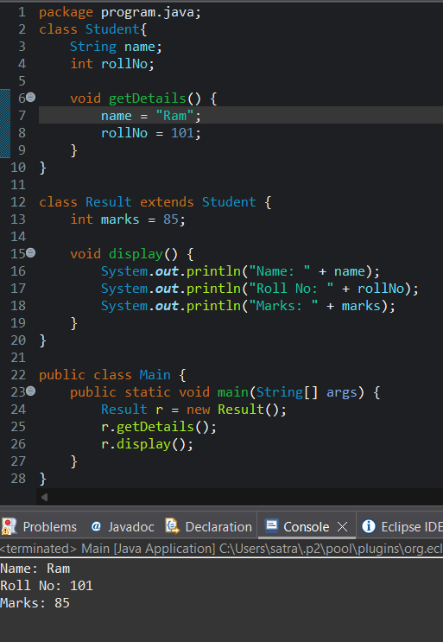
Name: RAM
Roll No: 101
Marks: 85

2. Bank Account System (Hierarchical Inheritance)
Question:
A bank has Savings and Current accounts. Both inherit from a common Account class.
Code:
class Account {
void showAccountType() {
System.out.println("Bank Account");
}
}

class SavingsAccount extends Account {
void interest() {
System.out.println("Savings Account gives interest");
}
}

class CurrentAccount extends Account {
void overdraft() {
System.out.println("Current Account supports overdraft");
}
}

public class Main {
public static void main(String[] args) {
SavingsAccount s = new SavingsAccount();
CurrentAccount c = new CurrentAccount();

s.showAccountType();
s.interest();

c.showAccountType();
c.overdraft();
}
}

Output:

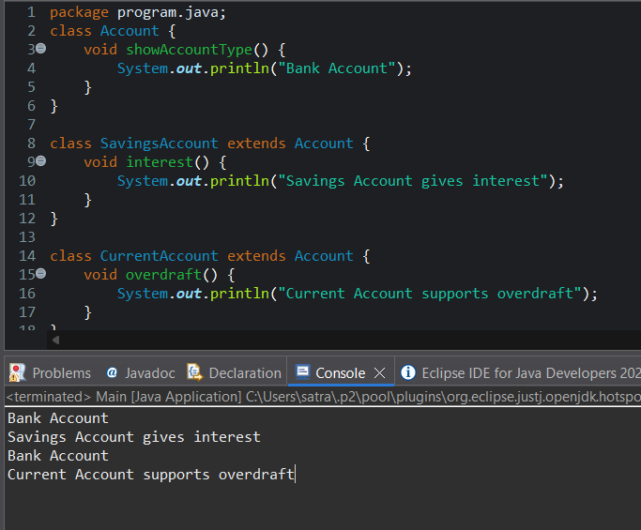
Bank Account
Savings Account gives interest
Bank Account
Current Account supports overdraft

3. Vehicle System (Multilevel Inheritance)
Question:
A company classifies vehicles as Vehicle → Car → ElectricCar.
Code:
class Vehicle {
void start() {
System.out.println("Vehicle starts");
}
}

class Car extends Vehicle {
void fuelType() {
System.out.println("Car uses petrol");
}
}

class ElectricCar extends Car {
void battery() {
System.out.println("Electric car uses battery");
}
}

public class Main {
public static void main(String[] args) {
ElectricCar e = new ElectricCar();
e.start();
e.fuelType();
e.battery();
}
}
Output:
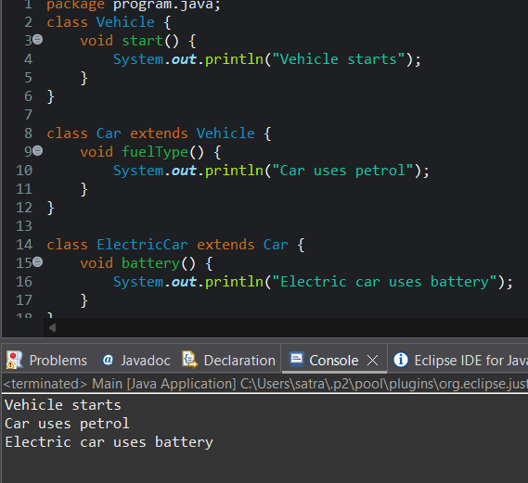
Vehicle starts
Car uses petrol
Electric car uses battery
POST LAB EXERCISE
- Why Java does not support multiple inheritance using classes and how it is implemented?
Java does not support multiple inheritance using classes to avoid ambiguity and complexity, especially the Diamond Problem (when two parent classes have the same method).
Java achieves multiple inheritance using interfaces, because interfaces contain method declarations (and no conflicting implementation).
- What is the role of the super keyword? Give examples.
The super keyword is used to refer to the parent class object.
Uses:
- Access parent class variables
- Call parent class methods
- Invoke parent class constructor
Example:
class Parent {
int x = 10;
}

class Child extends Parent {
void display() {
System.out.println(super.x);
}
}
- Can a child class access private members of the parent class? Why?
No, a child class cannot access private members of the parent class directly.
Reason:
private members are accessible only within the same class to maintain data encapsulation and security.

- Explain why hybrid inheritance is not supported in Java.
Hybrid inheritance combines multiple inheritance types, which may cause method ambiguity and complexity.
Java does not support it with classes to:
- Avoid confusion
- Prevent the Diamond Problem
- Keep the language simple and secure
However, hybrid inheritance is possible using interfaces.

Result:

Thus the different types of inheritance were implemented and executed successfully.

ASSESSMENT

Description | Max Marks | Marks Awarded
Pre Lab Exercise | 5
In Lab Exercise | 10
Post Lab Exercise | 5
Viva | 10
Total | 30
Faculty Signature

